Neoprene Hex Dumbbells Weights, Pair, Home Gym Fitness Aerobic Exercise Weight Solid Iron Pair, Orange, 5 KG X 2
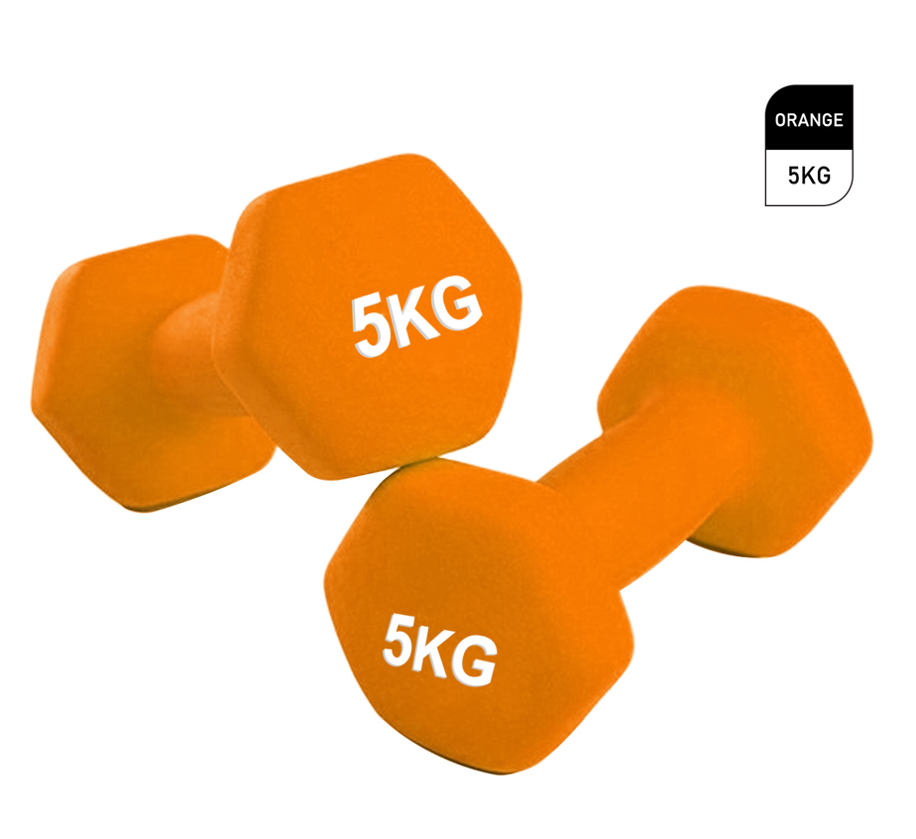

About this item
- NEOPRENE COATING for protection and impact resistance.
- SOFT & EASY TO GRIP | Neoprene dumbbells are made from solid cast iron for top quality durability. They are coated with neoprene to ensure an easy, soft and comfortable grip.
- NON-SLIP SURFACE | Even when you've worked up a sweat, making them far easier to handle during a training session than their vinyl or metal versions.
- BUILD YOUR MUSCLE | Great for building up your strength and muscle toning.
- COLOUR CODED | Each dumbbell is colour coded and has the weight printed on the end so it can quickly and easily be identified making it perfectly suited to fast moving, intense circuit training sessions.

Technical Details
Color | ‎Orange
Size | ‎5 KG X 2
Material type | ‎Neoprene, Iron
Batteries included? | ‎No
Brand | ‎LMS Data
Manufacturer | ‎LMS Data
Manufacturer reference | ‎DBELL-HEX2-5-ORG
Package Dimensions | ‎27 x 12 x 10 cm; 5 Kilograms
ASIN | ‎B09BBB935B

Product description
The NEO Neoprene Dumbbells Weights
Features
- The Neo neoprene dumbbells are made from solid cast iron for top quality durability. They are coated with neoprene to ensure an easy, soft and comfortable grip even when you've worked up a sweat, making them far easier to handle during a training session than their vinyl or metal versions.
- These high-grade dumbbells are perfect for building up strength and toning muscles, helping you to get the most out of your exercises. Ideal for bicep curls, lateral raises, bent-over rows, upright rows, overhead shoulder presses, overhead triceps extensions, triceps kickbacks and much more. Each dumbbell is colour coded and has the weight printed on the end so it can quickly and easily be identified making it perfectly suited to fast moving, intense circuit training sessions.
Specifications
  - Neoprene coating for protection and impact resistance
  - Soft and easy to grip
  - Non-slip surface
  - Great for building up your strength and muscle toning
  - Available in 1kg, 1.5kg, 2kg, 3kg, 4kg and 5kg

Part number: DBELL-HEX2-5-ORG

